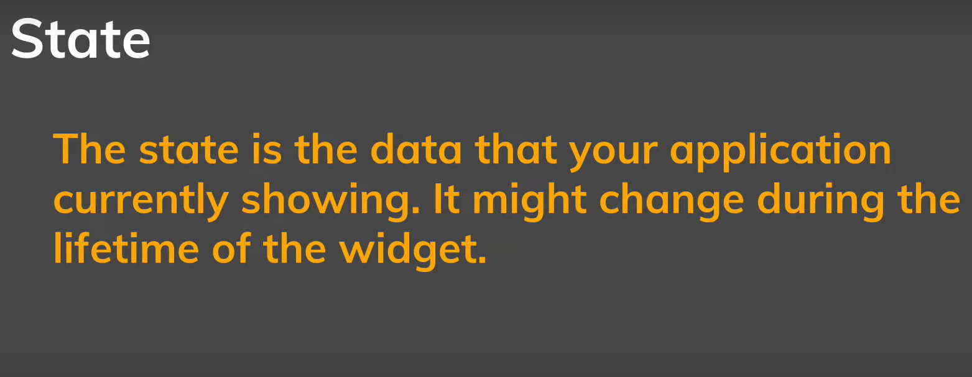

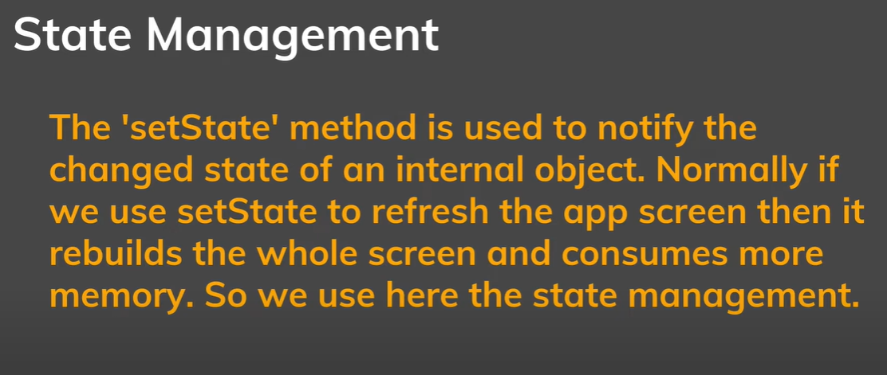

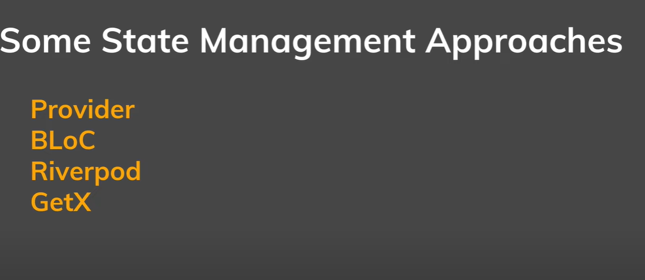

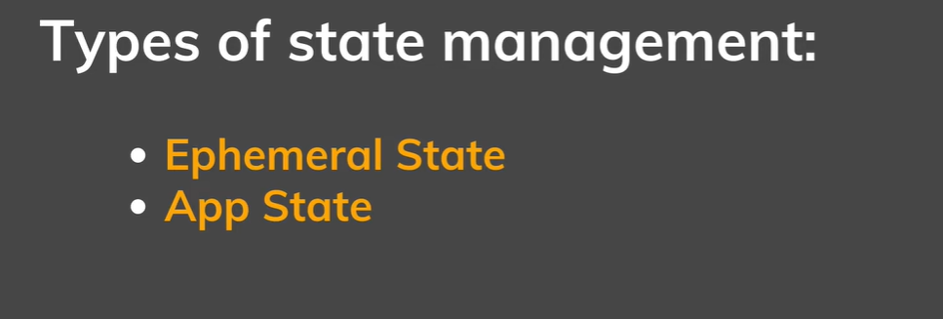

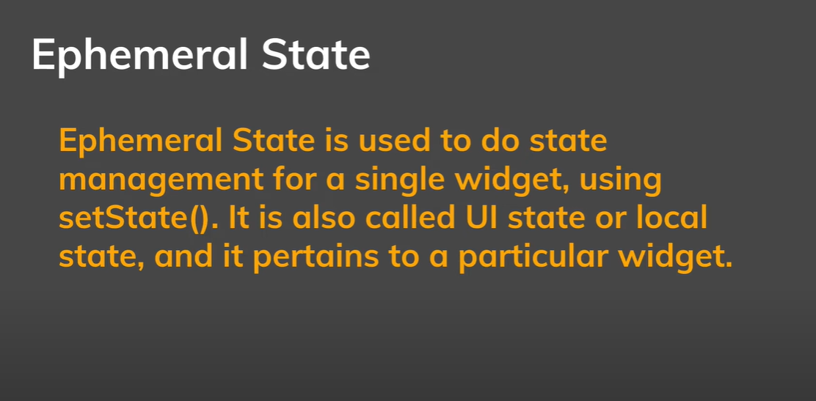

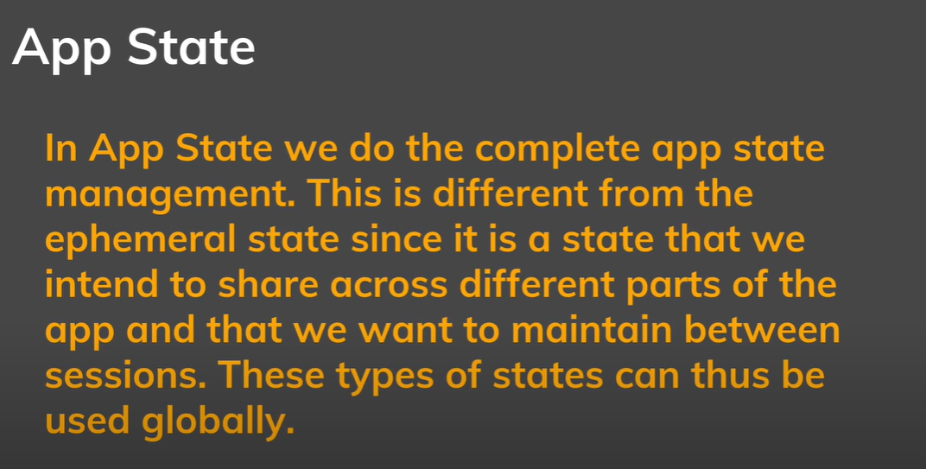

App develops by Flutter



• **Dream11**

• **Google Pay (Tez)**

• **My11Circle**

• **Flipkart**

• **Zomato**

• **OLA**

• **Tata Neu**

• **BookMyShow**

• **PayTM**

• **BigBasket**

• **PolicyBazaar**

• **Groww**

• **Myntra**

• **HDFC Bank Mobile Banking**